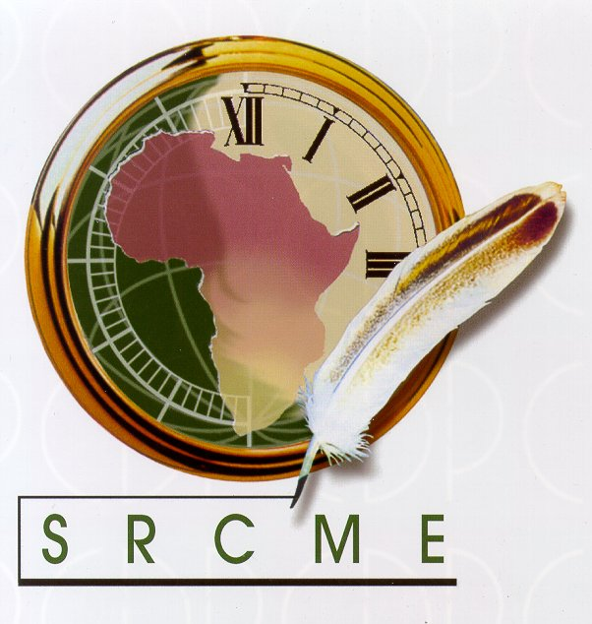

SADC RESOURCE CENTRE FOR METROLOGY EDUCATION

CERTIFICATE OF ATTENDANCE

This is to certify that:

Polo Leboela

Attended the

SADCMET Proficiency Test Scheme (Round 2): Evaluation Workshop

Courtyard Hotel, Dar es Salaam, Tanzania

10 - 11 October 2005

Merle Smuts Dr M. Koch (Service Provider) (PT Consultant)

Dr Mukayi T. Musarurwa
SADCMET Regional Coordinator

